Culinary Recommendation (Jogjakarta Edition)

1. Bakmi Jawa

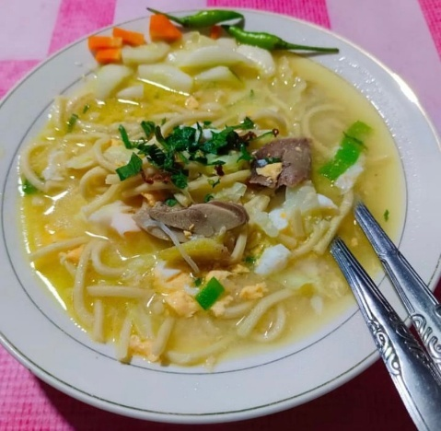

Description, category: NULL

Recommended place: Bakmi Pak Pele

Location: JL. Pojok Tenggara Jl. Alun-Alun Utara, Panembahan, Kecamatan Kraton, Kota Yogyakarta, Daerah Istimewa Yogyakarta 55131

More Info (operational hours,etc:

[Bakmi Pak Pele, Kuliner Legendaris yang Eksis Sejak Tahun 1983 |](https://kumparan.com/seputar-yogyakarta/bakmi-pak-pele-kuliner-legendaris-yang-eksis-sejak-tahun-1983-22DHENMhnTz) [kumparan.com](http://kumparan.com)

<https://g.co/kgs/GbnGK7b>

1. Gudeg

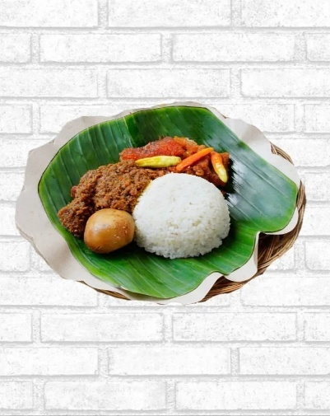

Description, category: NULL

Recommended place: Gudeg Yu Djum

Lokasi: Choose one from website

More Info (operational hours,etc:

[Gudeg Yu Djum](https://gudegyudjum.com/)

1. Belalang Goreng

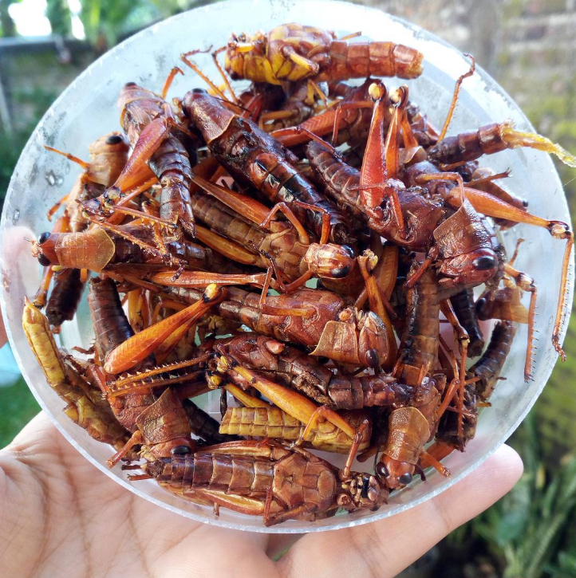

Desc and Recommended place:

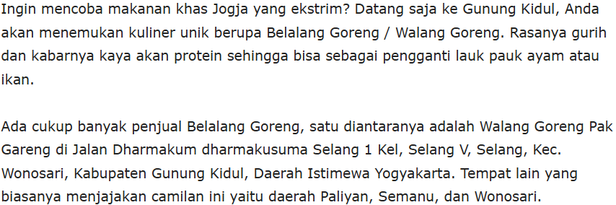

Category:

Lokasi: Gunung Kidul

Website: None

1. Mangut Lele

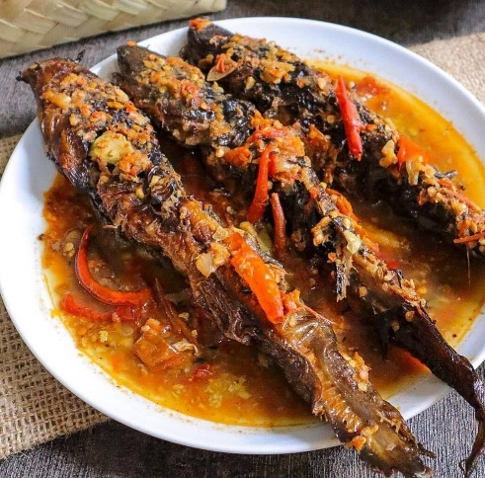

Description, category: NULL

Recommended place: Mangut Lele Mbah Marto

Lokasi: Jl. Sewon Indah, Ngireng-ireng, Panggungharjo, Kec. Sewon, Kabupaten Bantul, Daerah Istimewa Yogyakarta 55188

More Info (operational hour,etc):

[Mangut Lele Mbah Marto, Fasilitas, Lokasi, Harga Menu 2025 - TripJogja™](https://tripjogja.co.id/mangut-lele-mbah-marto/)

<https://g.co/kgs/M493YWd>

1. Soto Bathok

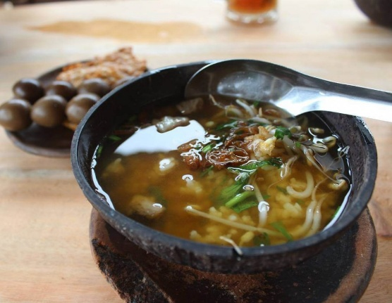

Description, category: NULL

Recommended place: Soto Bathok Mbah Katro

Lokasi: 6CQW+JRF, Sambisari, Purwomartani, Kec. Kalasan, Kabupaten Sleman, Daerah Istimewa Yogyakarta 55571

More Info (operational hour,etc):

[Soto Bathok Mbah Katro Daftar Harga Menu dan Lokasi | Homestay Jogja Guest House Jogja Terbaik, Yogyakarta - Official Site](https://homestaydijogja.net/soto-bathok-mbah-katro-daftar-harga-menu-dan-lokasi/)

<https://g.co/kgs/PCqTKgt>

1. Bakpia

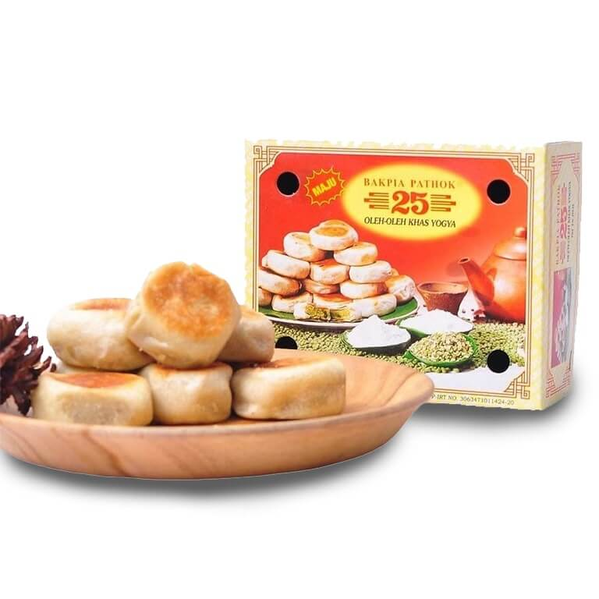

Description, category: NULL

Recommended place: Bakpia Pathok 25, Bakpiaku

Lokasi: Many(Usually in toko oleh-oleh)

More Info (operational hour,etc):

<https://www.nibble.id/bakpia-terenak-di-jogja/>